V1
...
2.2 Data Extraction
The procedure detailed above first requires delineating regions and producing time-series data describing the cumulative number of contribution operations. As theoretically the spatial extent of an event can range from sub-national to international, national boundaries do not present a useful geographic system for this analysis. Instead, a data-driven approach based on a quad-tree-like process was used to produce a spatial system. First, the globe was divided into four equal regions. Using the OSM History Database tool (OSHDB; Raifer et al., 2019), which allows querying and aggregating OSM history data in a flexible manner, the number of entities in each quadrant (according to the state of the database in April 2019) was counted. The procedure than recursively divided each cell into equally sized sub-quadrants until none of the sub-quadrants included 50,000 entities. The resulting division thus contains cells of varying sizes and number of entities, allowing for some cells containing a relatively low number of entities (in cases where the division of one cell produced some sub-quadrants with at least 50,000 entities and others with less). To reduce the probability of incorrect identification of events, cells with less than 20,000 entities were excluded from the analysis, resulting in 10,136 cells. Figure 5 in the results section below presents the outcome of this process.

...
3.3 Event Patterns
...
It is plausible to expect that this shift in practices would follow a geographical pattern – remote events, usually associated with humanitarian efforts, and local events have inherent ties to specific regions. Several related patterns are indeed evident in Figure 5. First, imports seem to be more frequent in developed regions and certain sections of South America – even early imports, despite being the most evenly distributed type of event, have more weight in developed countries such as the USA and France; late imports and especially geometry imports have little weight, if any, in the sub-Saharan region and in far-east Asia. Data in these latter regions are mainly attributed to remote events and, to a lesser extent, to local events. Therefore, the shift in practices also signifies a geographical shift from the global north towards less developed regions.
The patterns in Figure 5 can also be used to assess the validity of the event identification results, as they point to known events in OSM history. For example, tag import events are especially clustered in the USA. These events mostly take place between July 2009 and January 2010 (Figure 4) thus fitting with the 2009 import of the USGS Geographic Names Information System (OpenStreetMap, 2020j) – a database naming spatial entities and places in the USA, hence the focus on tag operations. Tag imports are therefore a unique phenomenon in OSM history and not a generic type of event. Beyond tag imports, early imports also produced much of the data in the USA due to the 2007 import of the Topologically InteGrated Encoding and Referencing system database (TIGER) produced by the US Census Bureau (Zielstra et al., 2013; OpenStreetMap, 2020i). The procedure also successfully identified other imports of national datasets, such as the 2009 import the French Cadaster database (OpenStreetMap, 2020g) and the Automotive Navigation Data import for the Netherlands (OpenStreetMap, 2020c). Also, the procedure manages to identify the contributions of humanitarian remote mapping efforts, such as the Haiti OpenStreetMap Response after the 2010 earthquake which led to the establishment of the Humanitarian OpenStreetMap Team (HOT; OpenStreetMap, 2020e,f) and the mapping efforts of this team after the 2015 Nepal earthquake (OpenStreetMap, 2020a).
<Insert Figure 5 here>
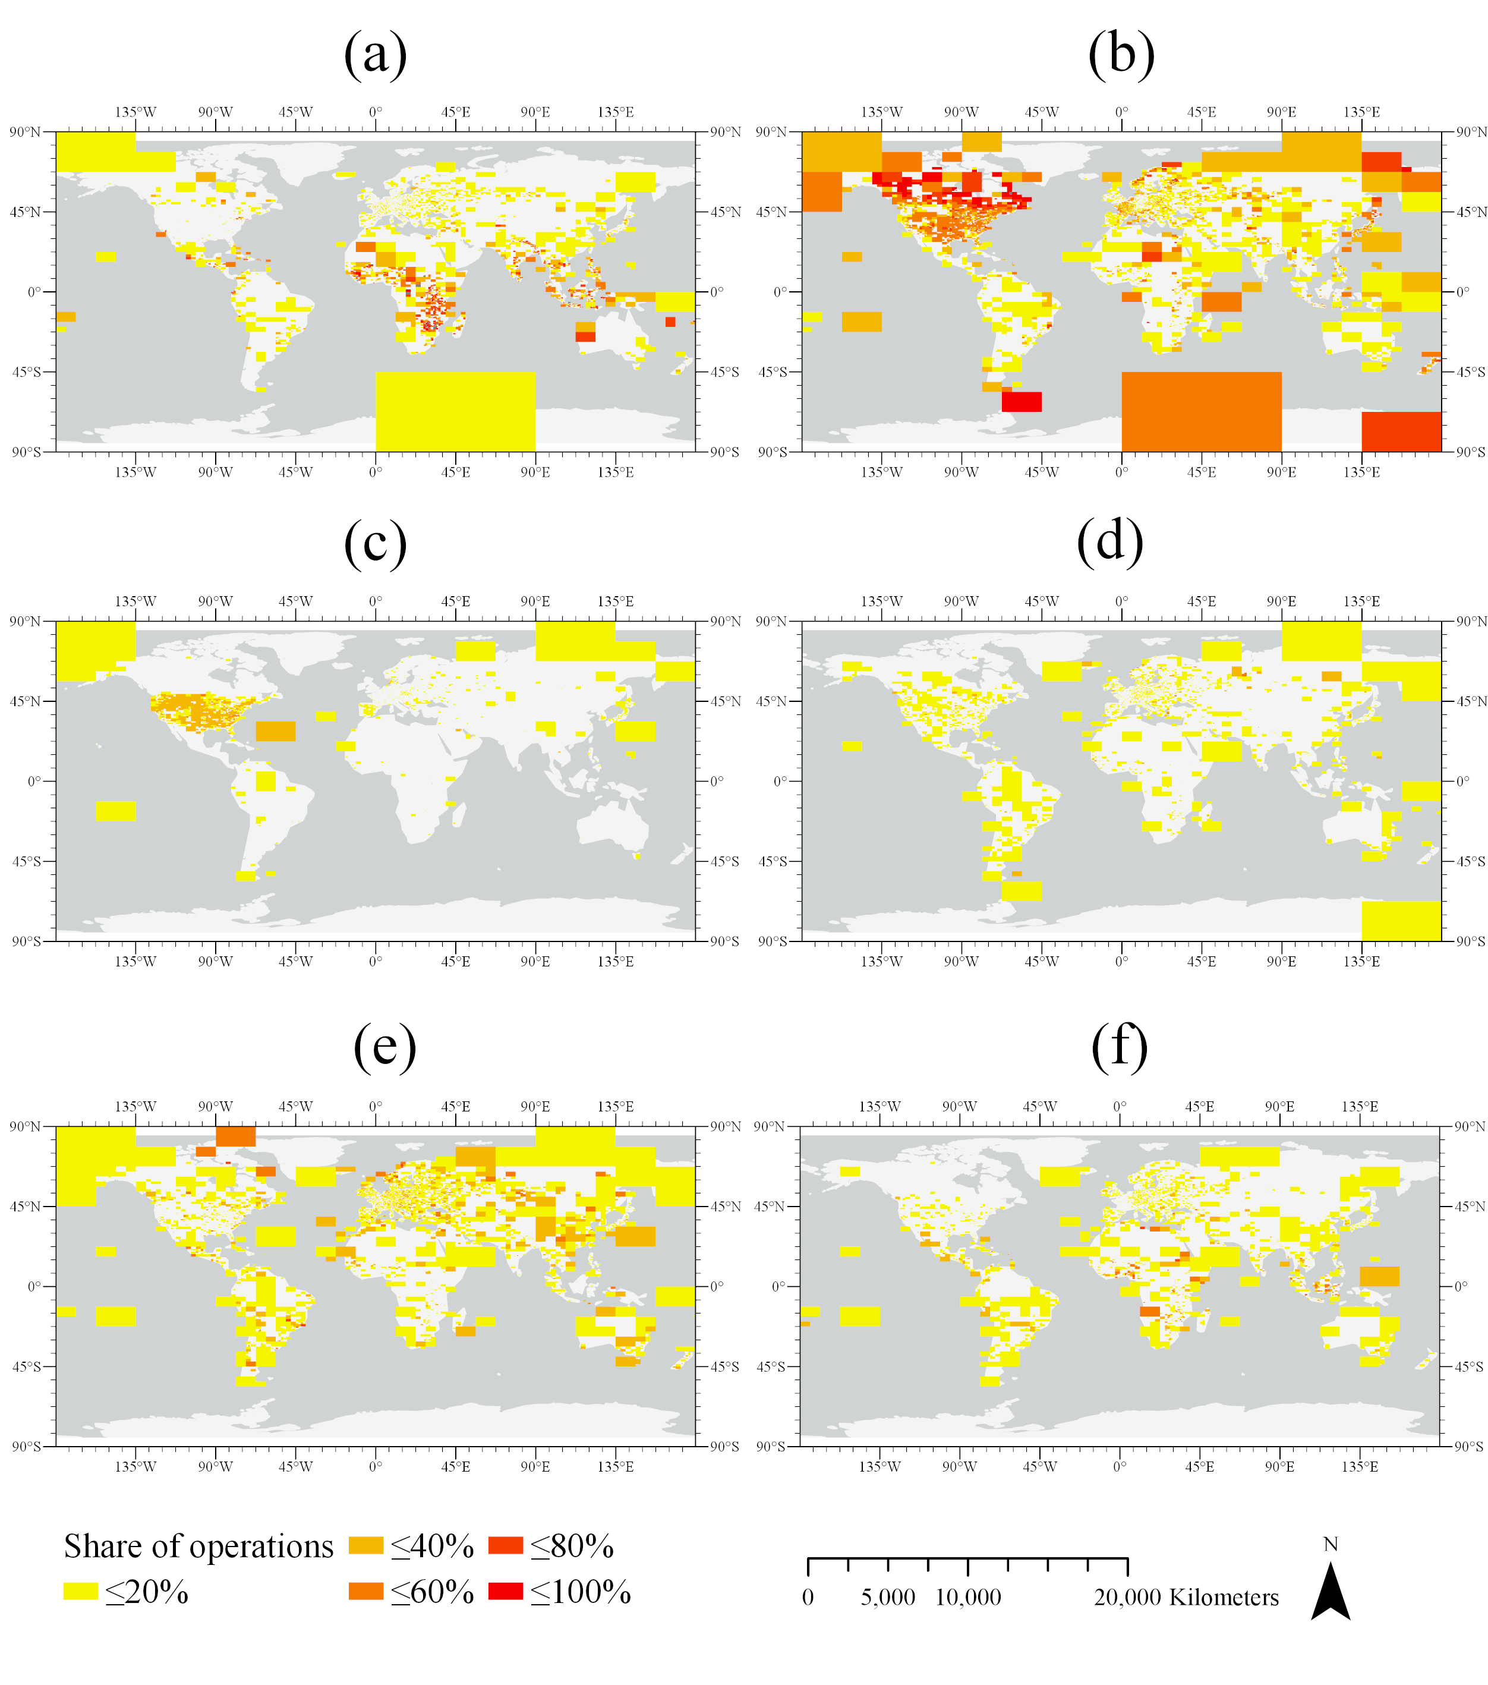
Figure 5. Events’ weights per cell by event type: (a) remote event, (b) early import, (c) tag import, (d) geometry import, (e) late import, (f) local event

Rev1

1 | Figure 5 - Perhaps it is just me, but I find this graphic difficult to follow. I wonder is it really required? Would a table indicating the number of events (approximately) in each continent work as an alternative? | This figure was revised and now presents the results at the level of individual countries for the sake of readability. Also, it uses the web Mercator projection so that European countries appear larger

2 | While figure 5 shows us a distribution of events, given the title of the paper I would also have expected some spatio-temporal clustering | We have revised the title of the manuscript using ‘spatial and temporal distribution’ instead of ‘spatio-temporal patterns’, to make sure the content of the paper will fit with readers’ expectations. We agree that spatio-temporal clustering could provide additional interesting insights but feel that these insights may go beyond the topic of the research presented here.

2 | figure 5: choice of projection in conjunction with size of squares not well-suited to support the main message; either reproject or find a way to focus on the areas with smaller grid cells (which have the more interesting results, I think) | This figure was revised and now presents the results at the level of individual countries for the sake of readability. Also, it uses the Web Mercator projection so that European countries appear larger

V2
4.3 Event Patterns
It is plausible to expect that this shift in practices would follow a geographical pattern – all event types, from remote events, usually associated with humanitarian efforts, through local knowledge events, and down to bulk imports have inherent ties to specific regions. To explore this, we computed for each country the median share of event operations (by event type) out of all operations over all cells within the country (Figure 5). Several related patterns are indeed evident in this figure. First, imports seem to be more frequent in developed regions and certain sections of South America – even early imports, despite being the most evenly distributed type of event, have more weight in developed countries such as the USA, France, Japan, and New Zealand; late imports and especially geometry imports have little weight, if any, in the sub-Saharan region and in far-east Asia. Data in these latter regions are mainly attributed to remote events and, to a lesser extent, to local knowledge events. Therefore, it seems that less developed regions do not experience this shift in practices the same way regions in the global north do.
The patterns in Figure 5 can also be used to assess the validity of the event identification results, as they point to known events in OSM history. For example, tag import events are especially clustered in the USA. These events mostly take place between September 2009 and January 2010 (Figure 4) thus fitting with the 2009 automated fixup (OpenStreetMap, 2020m) which aimed to remove four superfluous tags defined for each of the ~170 million nodes created during the 2007 import of the 2005 Topologically InteGrated Encoding and Referencing system database (TIGER) produced by the US Census Bureau. Tag imports are therefore a unique phenomenon in OSM history and not a generic type of event. Beyond tag imports, early imports also produced much of the data in the USA due to the 2007 TIGER import (Zielstra et al., 2013; OpenStreetMap, 2020l). The procedure also successfully identified other imports of national or local datasets, such as imports in the Netherlands and France (OpenStreetMap, 2020h). Also, the procedure manages to identify the contributions of humanitarian remote mapping efforts, such as HOT’s mapping efforts after the 2015 Nepal earthquake (OpenStreetMap, 2020a).

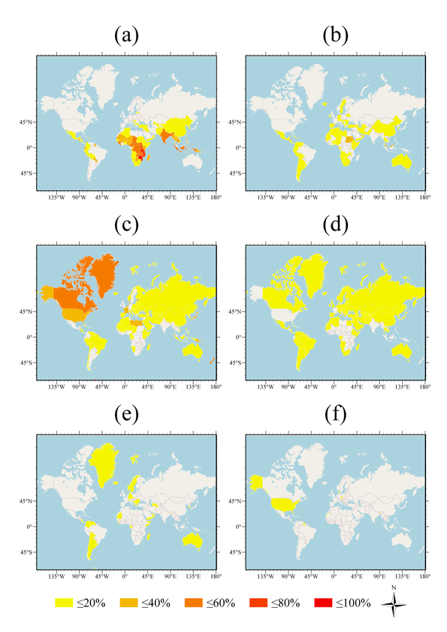
Figure 5. Median events weight by country and event type: (a) remote event, (b) local knowledge event, (c) early import, (d) late import, (e) geometry import, (f) tag import
209x296mm (72 x 72 DPI)

Rev 2
My single remaining request for revision concerns figure 5, which has, I am afraid, changed for the worse. My original comment was that some large cells in high latitudes in mostly sparsely populated areas dominate the maps, while interesting finer patterns elsewhere are not discernible. The change to a country-based choropleth map in Web Mercator projection has only aggravated the problem: Now the high latitudes have even larger prominence, and finer changes elsewhere have been aggregated into countries. I don't know how to solve the problem, but maybe start by considering equal area projections such as Behrmann or Albers conic, or compromises such as Robinson. Alternatively, instead of showing the entire earth without discernible detail, zoom in to an interesting region and interpret it as an example

